**WEEK 6 REACT**

**File 1:**

**App.js**

import React from 'react';

function App() {

  return (

    <div>

      <h1>welcome to the first session of React</h1>

    </div>

  );

}

export default App;

**OUTPUT:**

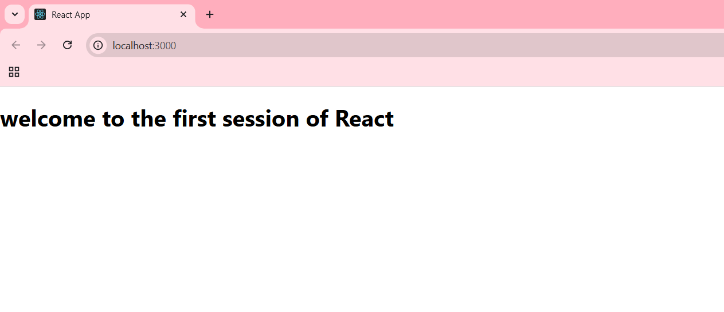

**File :2**

**APP.js**

import React from 'react';

import Home from './components/Home';

import About from './components/About';

import Contact from './components/Contact';

function App() {

  return (

    <div>

      <Home />

      <About />

      <Contact />

    </div>

  );

}

export default App;

**Home.js**

import React, { Component } from "react";

class Home extends Component {

  render() {

    return (

      <div>

        <h3>Welcome to the Home page of Student Management Portal</h3>

      </div>

    );

  }

}

export default Home;

**Contact.js**

import React, { Component } from "react";

class Contact extends Component {

  render() {

    return (

      <div>

        <h3>Welcome to the Contact page of the Student Management Portal</h3>

      </div>

    );

  }

}

export default Contact;

**About.js**

import React, { Component } from "react";

class About extends Component {

  render() {

    return (

      <div>

        <h3>Welcome to the About page of the Student Management Portal</h3>

      </div>

    );

  }

}

export default About;

**OUTPUT**

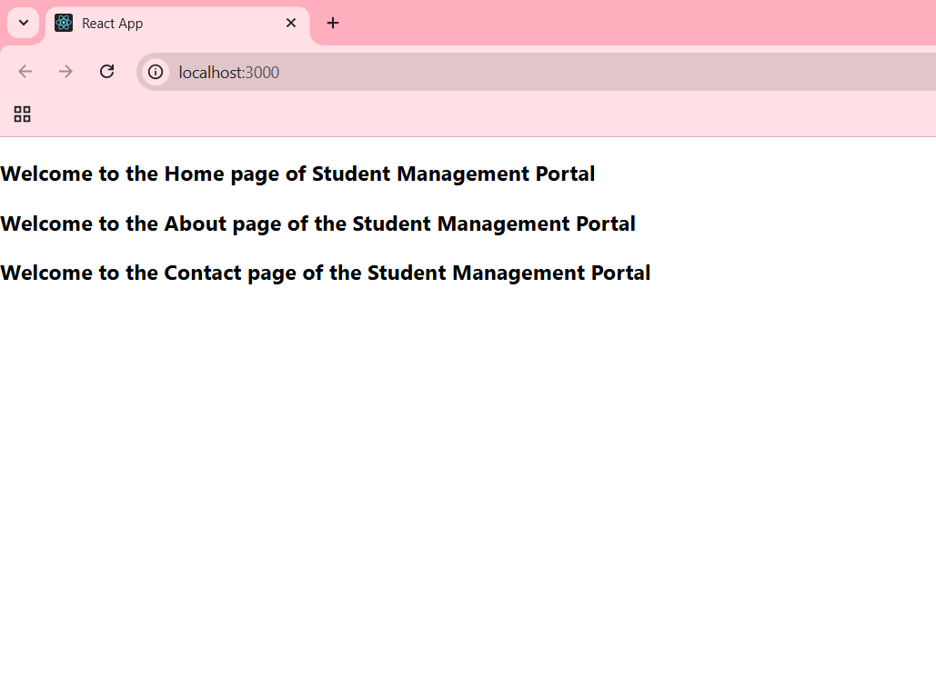

**File:3**

**CalculateScore.js**

import React from 'react';

import '../Stylesheets/mystyle.css';

function CalculateScore(props) {

  const average = props.Total / props.Goal;

  return (

    <div className="score-card">

      <h2>Student Score Calculator</h2>

      <p><strong>Name:</strong> {props.Name}</p>

      <p><strong>School:</strong> {props.School}</p>

      <p><strong>Total Marks:</strong> {props.Total}</p>

      <p><strong>Subjects:</strong> {props.Goal}</p>

      <p><strong>Average Score:</strong> {average}</p>

    </div>

  );

}

export default CalculateScore;’

**mystyle.css**

.score-card {

  background-color: #f5f5f5;

  border: 1px solid #ddd;

  padding: 20px;

  margin: 30px auto;

  width: 400px;

  text-align: left;

  font-family: Arial, sans-serif;

  border-radius: 10px;

  box-shadow: 0 2px 8px rgba(0,0,0,0.1);

}

.score-card h2 {

  color: #333;

  text-align: center;

}

.score-card p {

  font-size: 16px;

  margin: 8px 0;

}

**App.js**

.App {

  text-align: center;

}

.App-logo {

  height: 40vmin;

  pointer-events: none;

}

@media (prefers-reduced-motion: no-preference) {

  .App-logo {

    animation: App-logo-spin infinite 20s linear;

  }

}

.App-header {

  background-color: #282c34;

  min-height: 100vh;

  display: flex;

  flex-direction: column;

  align-items: center;

  justify-content: center;

  font-size: calc(10px + 2vmin);

  color: white;

}

.App-link {

  color: #61dafb;

}

@keyframes App-logo-spin {

  from {

    transform: rotate(0deg);

  }

  to {

    transform: rotate(360deg);

  }

}

**OUTPUT**

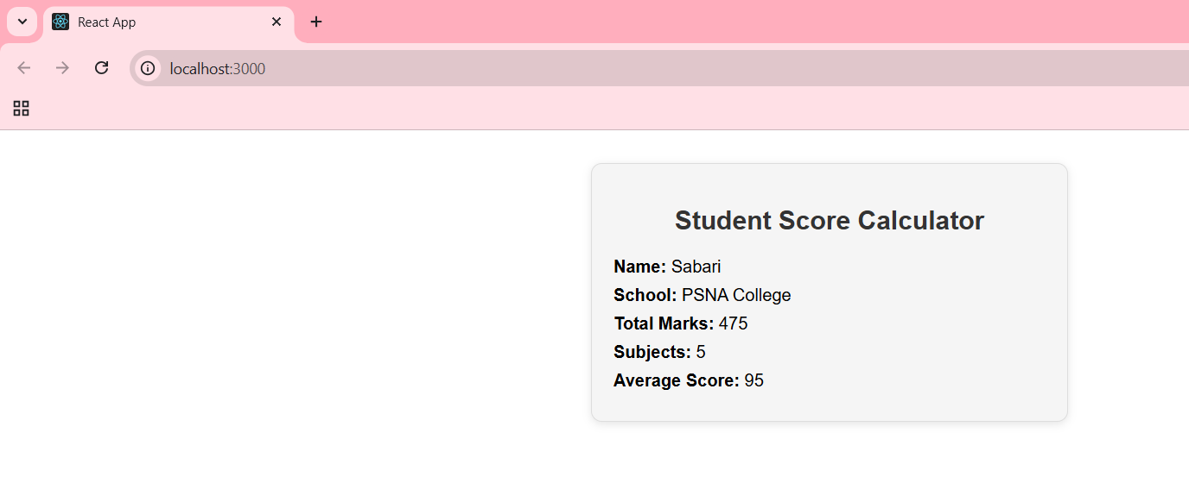

**File 4:**

**Post.js**

import React, { Component } from "react";

class Post extends Component {

  render() {

    return (

      <div style={{ border: "1px solid gray", padding: "10px", margin: "10px" }}>

        <h3>{this.props.title}</h3>

        <p>{this.props.body}</p>

      </div>

    );

  }

}

export default Post;

**Posts.js**

import React, { Component } from "react";

import Post from "./Post";

class Posts extends Component {

  constructor(props) {

    super(props);

    this.state = {

      posts: [],

    };

  }

  loadPosts() {

    fetch("https://jsonplaceholder.typicode.com/posts")

      .then((response) => response.json())

      .then((data) => {

        this.setState({ posts: data });

      })

      .catch((error) => {

        console.log("Error loading posts:", error);

      });

  }

  componentDidMount() {

    this.loadPosts();

  }

  componentDidCatch(error, info) {

    alert("An error occurred while rendering posts!");

    console.log("Error:", error, "Info:", info);

  }

  render() {

    return (

      <div>

        <h2>All Blog Posts</h2>

        {this.state.posts.map((post) => (

          <Post key={post.id} title={post.title} body={post.body} />

        ))}

      </div>

    );

  }

}

export default Posts;

**App.js**

import React from "react";

import Posts from "./Posts";

function App() {

  return (

    <div className="App">

      <Posts />

    </div>

  );

}

export default App;

**OUTPUT**

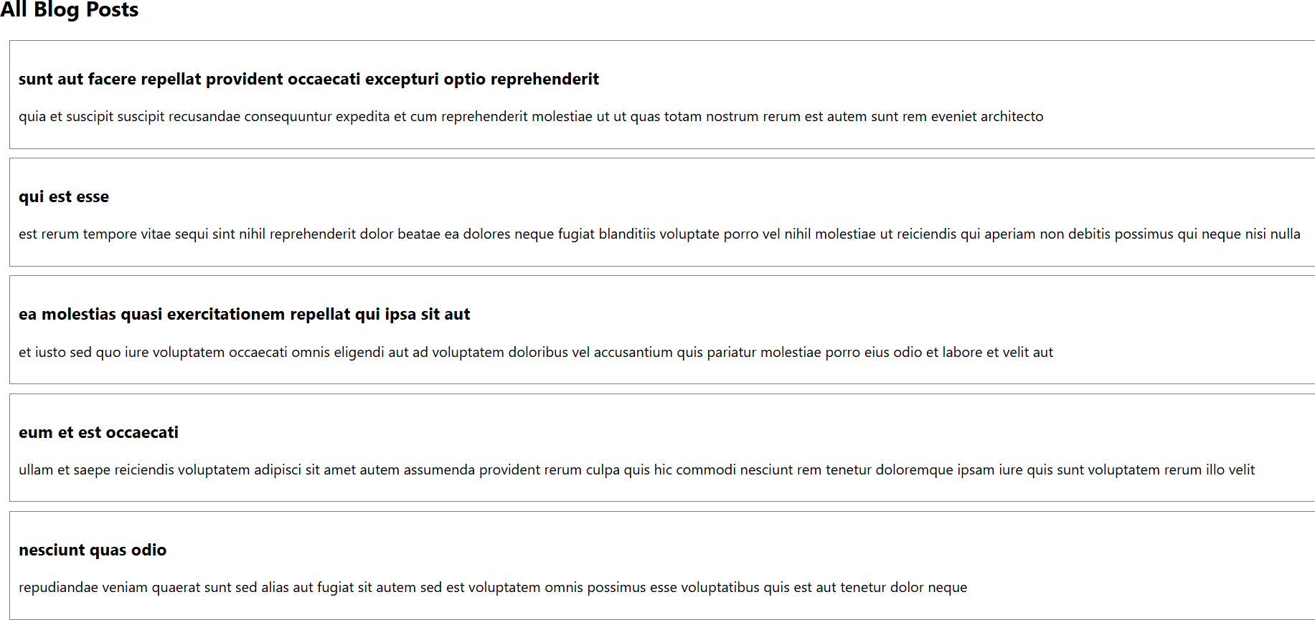

**File :5**

**App.js**

import React from 'react';

import CohortDetails from './CohortDetails';

function App() {

  const cohorts = [

    {

      name: 'React Training Batch 1',

      status: 'ongoing',

      startDate: '2025-07-01',

      endDate: '2025-09-30'

    },

    {

      name: 'Angular Training Batch 2',

      status: 'completed',

      startDate: '2025-04-01',

      endDate: '2025-06-30'

    }

  ];

  return (

    <div className="App">

      <h1>My Academy Cohort Dashboard</h1>

      {cohorts.map((cohort, index) => ( <CohortDetails key={index} cohort={cohort} />

      ))}

    </div>

  );

}

export default App;

**CohortDetails.module.css :**

import React from 'react';

import styles from './CohortDetails.module.css';

function CohortDetails({ cohort }) {

  return (

    <div className={styles.box}>

      <h3 style={{ color: cohort.status === 'ongoing' ? 'green' : 'blue' }}>

        {cohort.name}

      </h3>

      <dl>

        <dt>Status:</dt>

        <dd>{cohort.status}</dd>

        <dt>Start Date:</dt>

        <dd>{cohort.startDate}</dd>

        <dt>End Date:</dt>

        <dd>{cohort.endDate}</dd>

      </dl>

    </div>

  );

}

export default CohortDetails

**CohortDetails.js :**

/* import styles from './CohortDetails.module.css'; */

.box {

    width: 300px;

    display: inline-block;

    margin: 10px;

    padding: 10px 20px;

    border: 1px solid black;

    border-radius: 10px;

}

dt {

    font-weight: 500;

}

**OUTPUT**

